Dylan

Observations and Playtester Comments

# In-Game Observations

[Your thoughts as you watch the testers play]

* Now they know there is a restart option, but still a little hard to find
* The game is a little challenging if you do not know what you are doing

# In-Game Questions

Why did you make that choice? (to go into houses?)

* Thought I might be able to interact with them with space, but just got put inside instead

What did you think that would do? (choosing one choice over the other)

* Increase my empathy more than the other choice

What is confusing for you?

* Couldn’t find the restart options, but eventually won so it’s ok

# Postgame Questions

[Questions you ask the testers as they have played]

* Did you enjoy the backstory and being able to win?
  + Yes, if I couldn’t win, then I wouldn’t know how to restart cause I couldn’t find the option
* Did you like the bunny?
  + Yes he was super cute

## General Questions

What was your ﬁrst impression?

* The backstory text could be a little bigger since there is space, but the visuals were really nice

How did that impression change as you played?

* constant

Was there anything you found frustrating?

* Not being able to find where the restart option was in the game

Did the game drag at any point?

* When I was looking for the restart option, but gave up and eventually won

Were there particular aspects that you found satisfying?

* Transitioning between houses and outside was nice, and the sound effects were also on point

What was the most exciting moment in the game?

* Being able to finally win

Did the game feel too long, too short, or just about right?

* Just right

## Formal Elements

Describe the objective of the game.

* Make the right choices to increase your stats to win eventually

Was the objective clear at all times?

* After the first conversation, yes

What types of choices did you make during the game?

* What choice would be better for me and help me win

What was the most important decision you made?

* Choosing the right choices

What was your strategy for winning?

* Read which choices sounded better

Did you ﬁnd any loopholes in the system?

* no

How would you describe the conﬂict?

* You need to decide which choices will help you win, but want to explore other options too if possible, but this may cost you

In what way did you interact with other players?

* NA

Do you prefer to play alone or with human opponents?

* alone

What elements do you think could be improved?

* More conversations with choices

## Dramatic Elements

Was the game’s premise appealing to you?

* Eh, I enjoy these types of games occasionally

Did the story enhance or detract from the game?

* Made it better, yes, or else just walking around with no purpose

As you played, did the story evolve with the game?

* yes

Is this game appropriate for the target audience?

* yes

On a piece of paper, graph your emotional involvement over the course of the game.

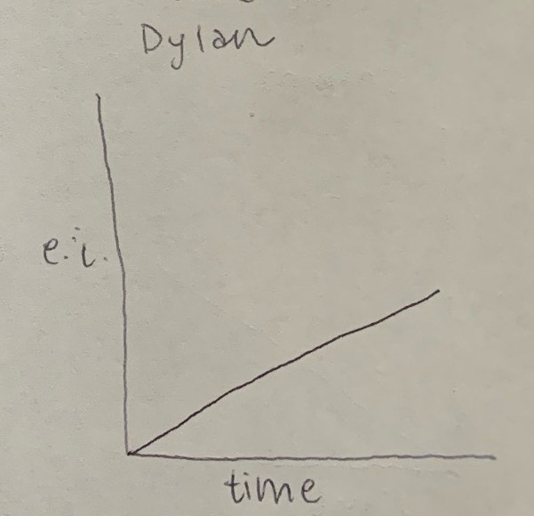

Did you feel a sense of dramatic climax as the game progressed?

* no

How would you make the story and game work better as a whole?

* Add more conversations

## Procedures, rules, interface, and controls

Were the procedures and rules easy to understand?

* yes

How did the controls feel? Did they make sense?

* Easy, use arrow keys

Could you ﬁnd the information you needed on the interface?

* yes

Was there anything about the interface you would change?

* no

Did anything feel clunky, awkward, or confusing?

* no

Are there any controls or interface features you would like to see added?

* no

## End of Session

Overall, how would you describe this game’s appeal?

* Rpg style game where you talk to people and see what you can do

Would you purchase this game?

* no

What was missing from the game?

* More conversations

If you could change just one thing, what would it be?

* Add more conversations

Who do you think is the target audience for this game?

* kids

If you were to give this game as a gift, who would you give it to?

* My little sister

# Revision Ideas

[Ideas you have for improving the game]

* Maybe make it a little easier? But there is a restart option so I guess keep same for now
* Maybe add more conversations